Play 3: Ages 7-11

Daphne O. Pack
Department of Home and Family, Brigham Young University-Idaho
CHILD310: Early and Middle Child Development
Brother Rowe
December 8, 2025

For this play assignment, I played improv games with my cousins over Thanksgiving break. This was inspired by two activities mentioned in the developmentally appropriate applications for 7-year-olds and 11-12-year-olds. The first application for 7-year-olds was to “offer dress-up clothes and props for planning and staging ‘original’ shows; encourage children to write their own stories or songs and be sure to attend their ‘performances’.” (Marotz, 2023). The second application for 11-12-year-olds was to “help children stage a play; invite them to write the script, design scenery, construct simple props, and rehearse.” (Marotz, 2023).
I played a variety of acting and improv games with my husband, siblings, and three cousins, one of whom is eight and another is eleven. It was like a mix of a bunch of stage plays with scripts written in the moment off the top of our heads, creating silly and random scenes with the props and background we were given. This was a form of play because it was pleasurable, intrinsically motivated, freely chosen, actively engaging, and a non-literal exploration of the imagination. For my youngest cousin Arthur especially, it was a challenge to be creative and come up with scenarios and stories in response to previous actions of the other participants. I could see his mind working around possibilities and imagining up new explanations for things.
This activity affected all areas of development like physical exertion and motor control (acting out complex scenes), perceptual-cognitive development (thinking about another person’s actions and opinions, building off of that), speech and language development (using new words to explain things, hearing adults and teenagers use more complex language), and social-emotional development (participating in a team game, following rules, being aware of self and others, and performing for others).
During this play activity I felt very energetic and free. It was fun being able to be creative and think outside the box by creating imaginary scenarios with others. This activity could not really be done alone but doing it with others helped not only the game to function but also fostered group unity and cooperation. It was great to bond as a family by doing something fun and seeing what everyone comes up with.
I can incorporate this play into my busy lifestyle as a student by taking time to be less serious and act out bits with my husband and friends for fun. I can also just create imaginary scenarios in my head to help put myself into the shoes of someone else to better understand them and their experiences. Another way is to incorporate this imagination into my class and personal art projects.
To adapt this play to a pre-school child, I would provide more props and costumes to aid their imagination. I would also let it be freer role-play rather than a game with structured rules on starting and changing scenes. Children are already gifted at improv. For older school-aged children I would add in simple rules to the game and make the props and costumes more abstract or eliminate them altogether to help them imagine things on their own. I would also provide opportunities ahead of time for them to create their own props with arts and crafts.
My personal play can help me relate to children because I have experienced and continue to experience the types of play they do. Keeping my imagination alive will help me to join children in their make-believe play and stories and appreciate their creativity. It will also help me to appreciate all intrinsically motivated and pleasurable activities as necessary play experiences for children that I should not hinder.

References
Marotz, L. R. (2023). Developmental profiles: Pre-birth through adolescence. 9, 187.
Marotz, L. R. (2023). Developmental profiles: Pre-birth through adolescence. 9, 219.

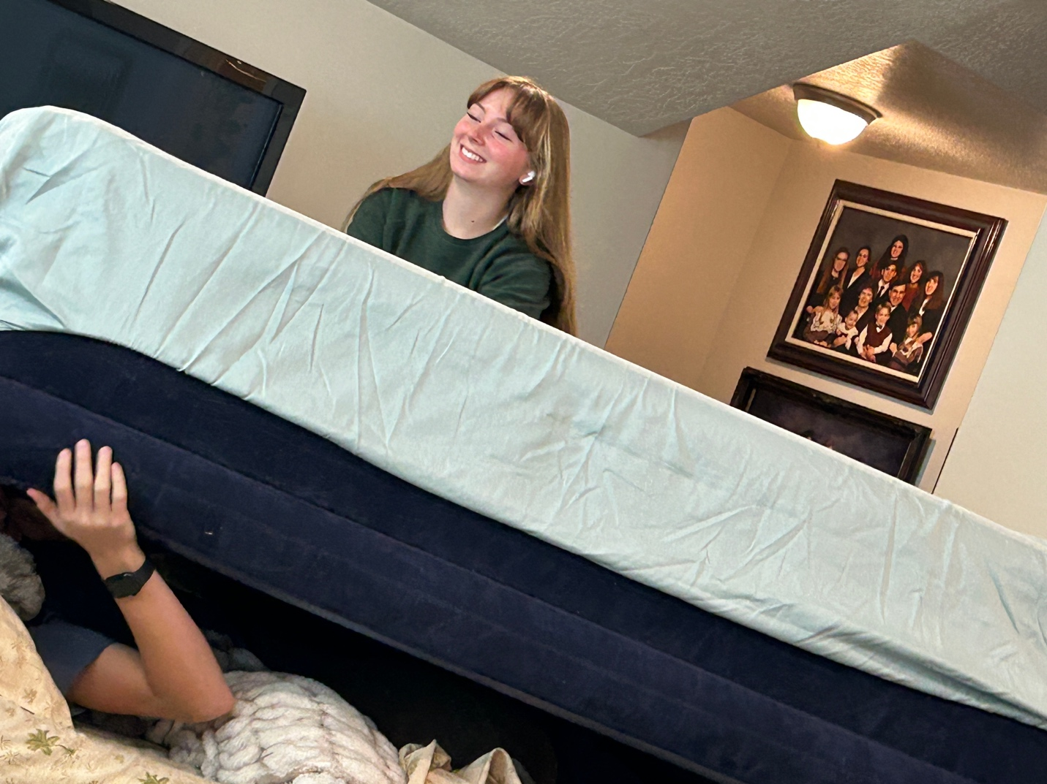
I didn’t get a very good picture of the game (we were too into it), but here’s my sister burying my brother under an air mattress.

